**EXP_ DESIGN AN AUTOMATIC NIGHT LIGHTING SYSTEM**

**THEORY**

**CIRCUIT DIAGRAM:** 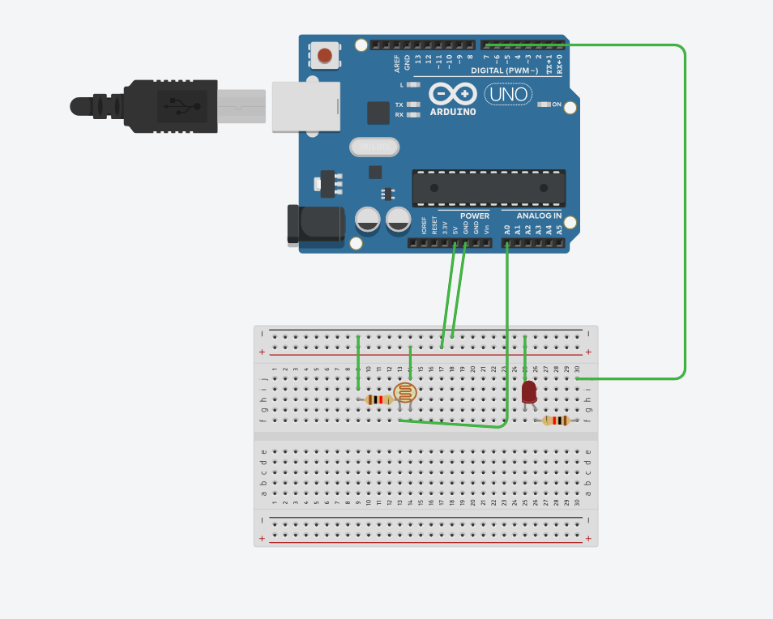

**CONCEPT USED :** In this experiment first we used the basics of electronics in connecting the breadboard connections and the concept of light dependent resistor(ldr).

**LEARNING AND OBSERVATIONS**:

Through this experiment we can learn the use and the applications of light dependent resistor.

The connections of ldr should be connected properly to the breadboard and the Arduino.

**PROBLEMS AND TROUBLESHOOTING :**

We mainly face problems in connecting the breadboard connections and the connections of ldr.

And the code of the Arduino should be given properly.

**PRECAUTIONS :**

One should be very consciouswhile making the connections of breadboard and ldr.

And also the code of Arduino should be checked twice.

The use of extra connecting wires should be decreased.

**LEARNING OUTCOMES :**

We can Learn the applications of light dependent resistor from this experiment.

The coding for Arduino can be done.